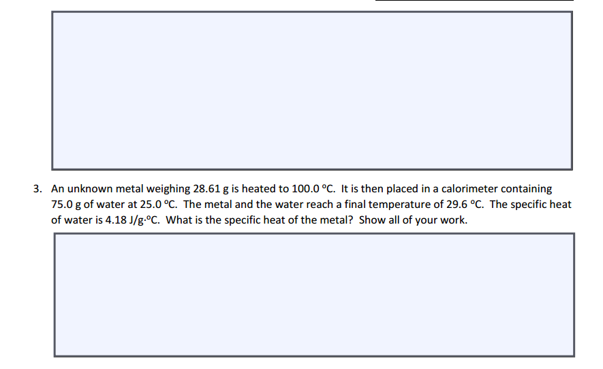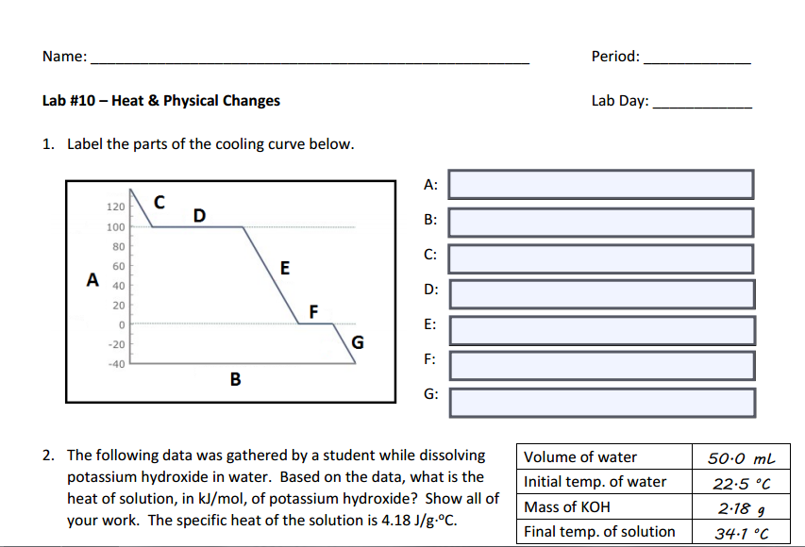

75(29.6-25)(4.18)= - 28.61 (29.6-100) C

C = 0.71859... joules per grams \* Celsius

50mL H2O () = 50g H2O 50g H2O + 2.18g KOH = 52.18g solution  
△H = 52.18g \* 4.18 \* (34.1-22.5) C △H = 2530.10384 joules 2.18g KOH () = 0.0139649...moles 50g H2O(=2.77542...moles

2530.10384 joules () (=0.907068.... kJ/mol

Solid

Freezing

Liquid

Condensation

Gas

Time

Temperature

4-5  
  
A2

Jonathan Quang